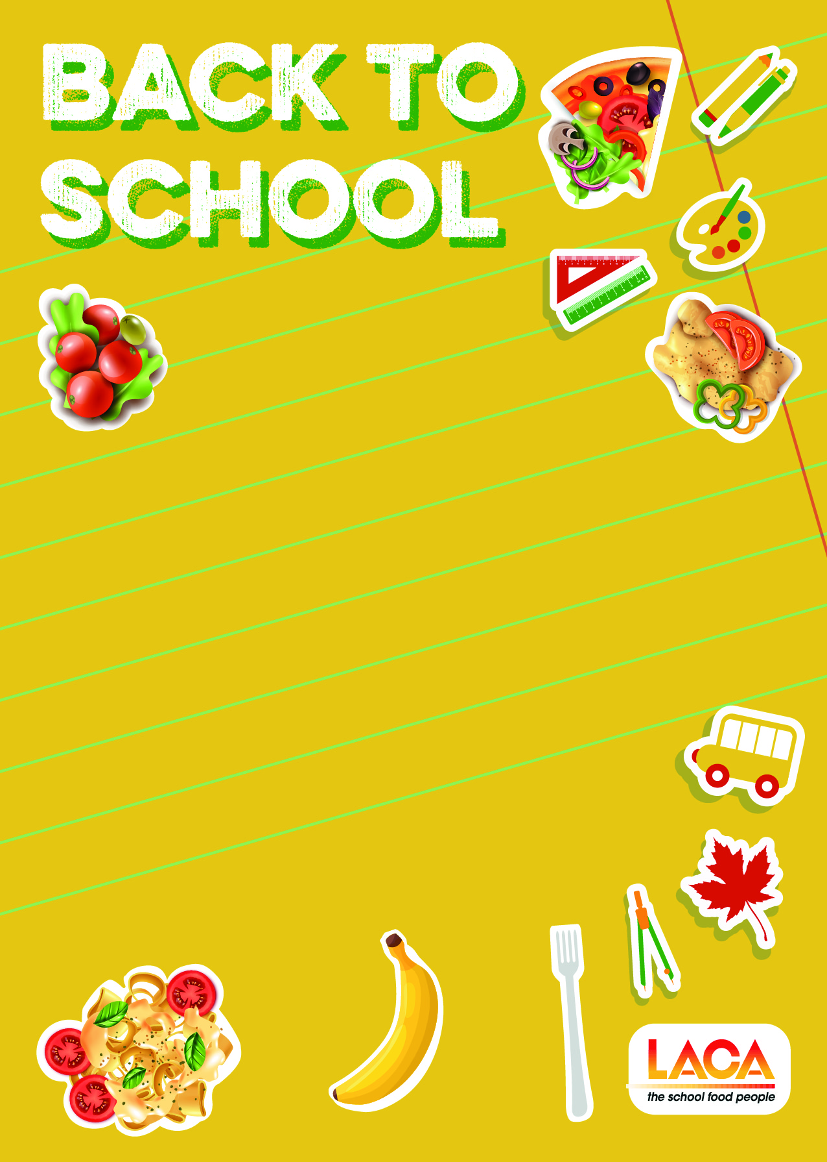

(Insert school/company logo here)

Dear Parent,

**Back to school lunch**

We are having a special menu on (insert date here) to celebrate the return to school. We would be delighted if your child could attend. There will be fun activities on the day too.

We will be serving

(Insert menu here)

Enjoying a nutritious two course school meal at lunchtime supports academic attainment, helps children to concentrate better and has a positive impact on behaviour in the classroom. It will also save you time in the mornings to sit down for a family breakfast and save money by reducing the times you might have to go shopping for lunch ingredients.

Please fill in the details below to let your school know you are taking part.

If you are entitled to free school meals your child will receive the meal in the normal way.

(Edit as required)

(Insert meal price, days of the week, how to pay, how to inform school)

We look forward to serving your child a delicious hot meal

Thank you for your ongoing support.