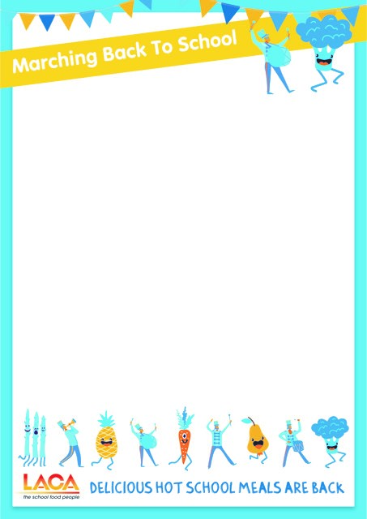

(Insert school/company logo here)

Dear Parent,

**We are back - Hot School Lunches are now available**

We are delighted to announce that many schools across the country, including yours, are taking part in a national campaign designed to make it possible for pupils to get back to eating a delicious hot two course meal at lunchtime as soon as possible

Enjoying a nutritious two course school meal at lunchtime supports academic attainment, helps children to concentrate better and has a positive impact on behaviour in the classroom. It will also save you time in the mornings to sit down for a family breakfast and save money by reducing the times you might have to go shopping for lunch ingredients.

Please fill in the details below to let your school know you are taking part in Marching Back To School. If you are entitled to free school meals your child will receive the meal in the normal way. (edit as required)

(Insert meal price, days of the week, how to pay, how to inform school)

We look forward to serving your child a delicious hot meal once more .

Thank you for your ongoing support.