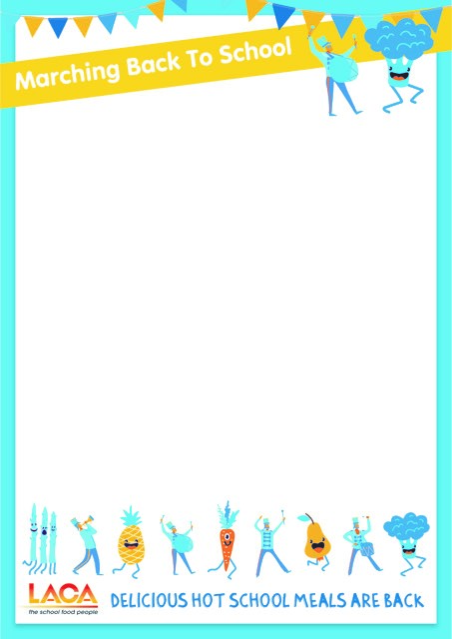

Dear Caterer

Another great LACA initiative to encourage schools to get as many children back to eating delicious hot meals ASAP

We understand the return to school has been challenging when it comes to providing meals at lunchtime. Some schools are still choosing packed lunches and we know retailers are promoting the voucher scheme to parents. As springtime approaches, we want to help school caterers return to serving hot cooked meals as soon as it is practicable and safe to do so. We all know the part school lunches play when it comes to concentration and attainment.

LACA’s latest initiative – Marching Back To School – has been created to encourage conversations between caterers, school representatives, on site staff and parents, to facilitate the return of hot lunches as soon as everyone feels it safe to do so. We do understand many school caterers have continued to serve hot meals, sadly others have been stopped completely.

We also believe it is important to promote the benefits to parents too, many may be reluctant to send their child back to the dining room. We have a whole host of resources you can use.

As the name of the initiative suggests, it can promoted from March onwards and can be continued through to Easter. We know this might not be possible for all and, in reality, schools may want to start in the summer term– the aim of the promotion is to keep the conversation going – caterers being able to refer to a National Initiative.

Marching Back resources are available and can be downloaded for free at www.thegreatschoollunch.co.uk/resources. We have created everything you need to return to serving meals to as many children as it is safe to do so.
Resources include
- Editable posters
- Healthy eating posters
- Letter to Head Teachers
- Letter to Catering Managers

- Banners
- Stickers

Thank you for your ongoing support.

