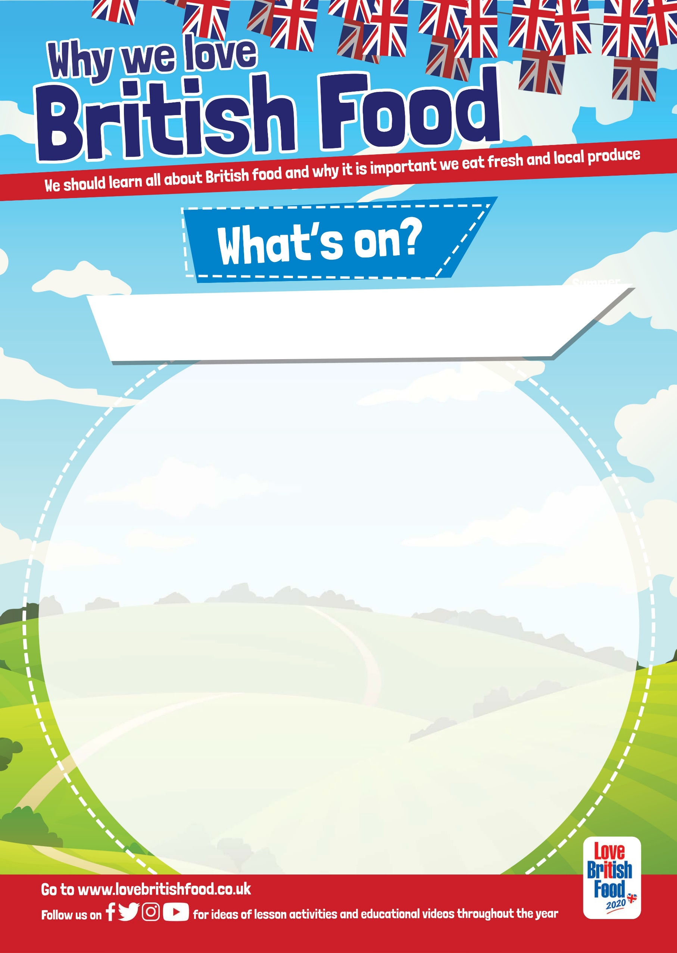

Why not plan some lessons to accompany The Great British Lunch

supported by Love British Food. [www.lovebritishfood.co.uk](http://www.lovebritishfood.co.uk) is easy to

navigate and is full of information, including the school guides with

suggested lesson plans. Please see the links below to help you plan.

<https://www.lovebritishfood.co.uk/teacher-zone>

<https://www.lovebritishfood.co.uk/advice-from-butchers>

<https://www.lovebritishfood.co.uk/lucy-williamson-discusses-british-milk>

<https://www.lovebritishfood.co.uk/whats-in-season-when>

Love British Food - Key Messages for Children

1. Britain has a huge range of diverse and delicious food available throughout the seasons that can be enjoyed.

2. Eating seasonal produce at the right time of year is delicious and healthy as the seasonal produce is packed full of nutrients, minerals and trace elements your body needs at that specific time of year.

3. Eating local produce can be fun as well as tasty as you explore the different food your region is known for.

4. Buying British food is better for the environment, the food has less far to travel from farm to shop so has a lower carbon footprint than imported food.

5. British meat is produced to some of the highest welfare standards in the world.

6. Buying British supports the economy, everyone from the farm to those who work in food processing and the shops, pubs and restaurants that serve the food.

7. Buying British means you play a part in protecting our environment as much of our food is produced in a sustainable way that enhances the countryside.

8. No sheep, no cows, no grains, no countryside!

Visit [www.thegreatschoollunch.co.uk/resources](http://www.thegreatschoollunch.co.uk/resources) to download

posters, stickers, activity sheets and much more

Lesson plans for National School Meals Week 2020