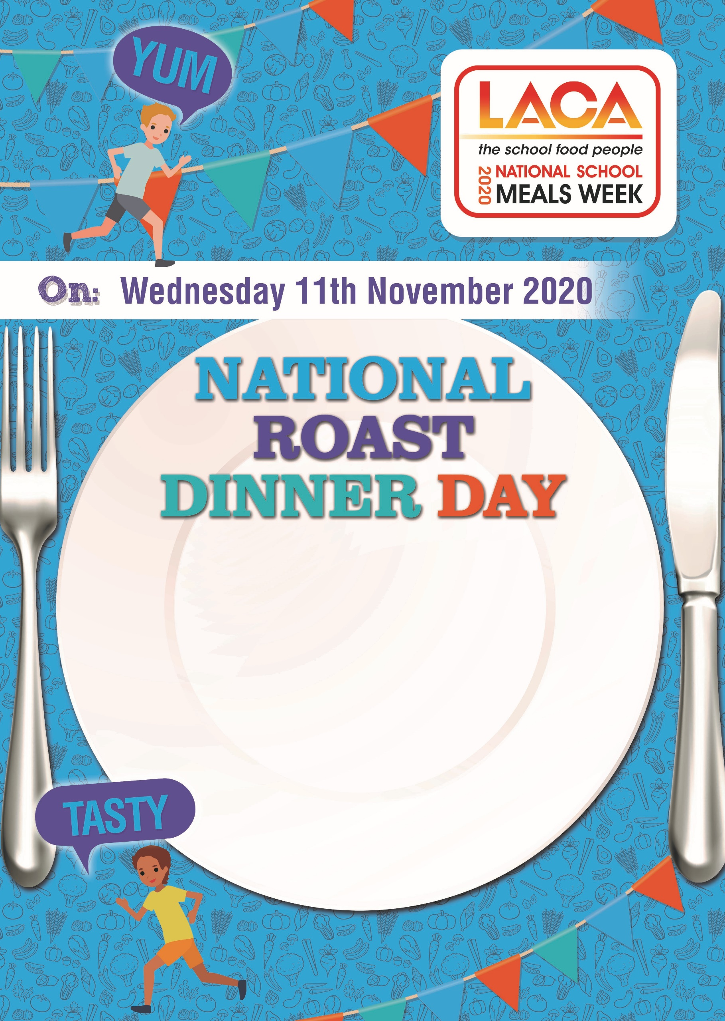

Amend and delete as appropriate

Dear Parent

On Wednesday 11th November schools across the country will be serving a roast lunch to celebrate National Roast Dinner Day. A day where we want as many children as possible to enjoy one of their favourite meals.

We are delighted to have the support of The Soil Association, please visit [www.soilassociation.org](http://www.soilassociation.org) to find out more about the work they do on food and farming.

We will be serving a menu of

Add your menu here

We would be delighted if your child could join in the special event.

Please let the school office know and pay in the usual way.

Free school meal children will automatically receive this meal.

We look forward to serving your child