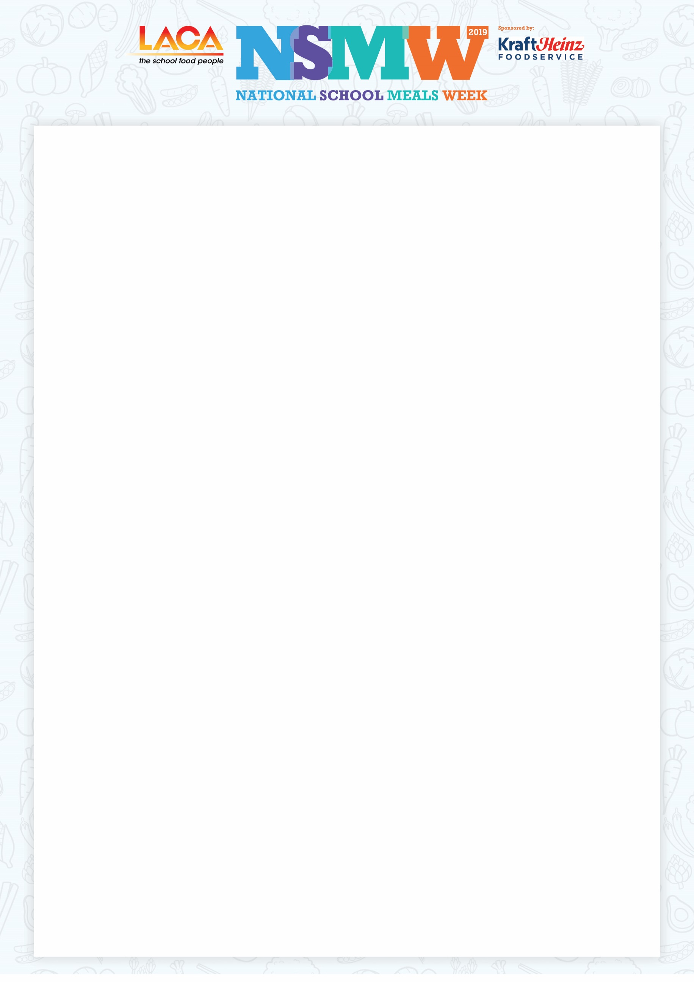

(Insert school/company logo here)

Dear (insert Lord Mayor/Lady Mayor/Mr Mayor/Madam Mayor depending on whether a city or a town)

LACA National School Meals Week (NSMW) is the one week in the year when we celebrate all that is great about today’s school food, with this year’s activities scheduled for 11th - 15th November 2019.

We would be most honoured if you would accept an invitation for you and (the Lady Mayoress/Madam Mayor’s Consort, delete as applicable) to join us for lunch on any day during that week and help mark the celebrations. We have also extended an invitation to our local MP (insert MP’s name) along with members of the council that represent our ward

LACA (The School Food People), sit at the heart of school food delivery, representing over 3,300 different organisations and individuals, all dedicated to ensuring that our children get the benefits from a healthy, nutritious school lunch.

Schools across the country are promoting the ‘Taste for Yourself’ campaign, which is an initiative for pupils who don’t have a school meal to sample a delicious two course lunch. Enjoying a nutritious two course school meal at lunchtime supports academic attainment, helps children to concentrate better and has a positive impact on behaviour in the classroom. We want every pupil to have that opportunity and in many cases it will be the only hot meal that some children have all day.

We would be delighted if you are able to join us for lunch during NSMW and if you would let us know which day of the week would suit you best, we will be happy to confirm timings, parking arrangements etc.

Your early reply to (insert name and contact details including DD telephone numbers and email addresses) will be appreciated and I look forward to hearing from you.