Dear parents,
This January, Change4Life has launched a new campaign all about snacking!
Did you know half the sugar kids eat comes from unhealthy snacks and sugary drinks? Too much sugar can lead to harmful fat building up inside and serious health problems, and also painful tooth decay.
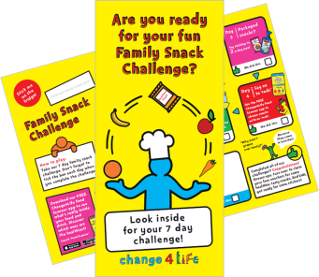
To help you reduce the amount of sugar your children are consuming, remember fruit and veg are always the best snack, and count towards your child’s 5 A Day. But if you are giving your children packaged snacks, stick to two a day max!

<Insert information about activities happening in your school to encourage healthier snacking>
Look out for the Family Snack Challenge that will be sent home in your child’s book bag in January. Can your family complete the 7-day healthier snack challenge?

Sign up on the Change4Life website to receive money-off vouchers for healthier snacks and lots of helpful tips and ideas.

Happy New Year from Change4Life!
<SCHOOL CLOSING MESSAGE>

