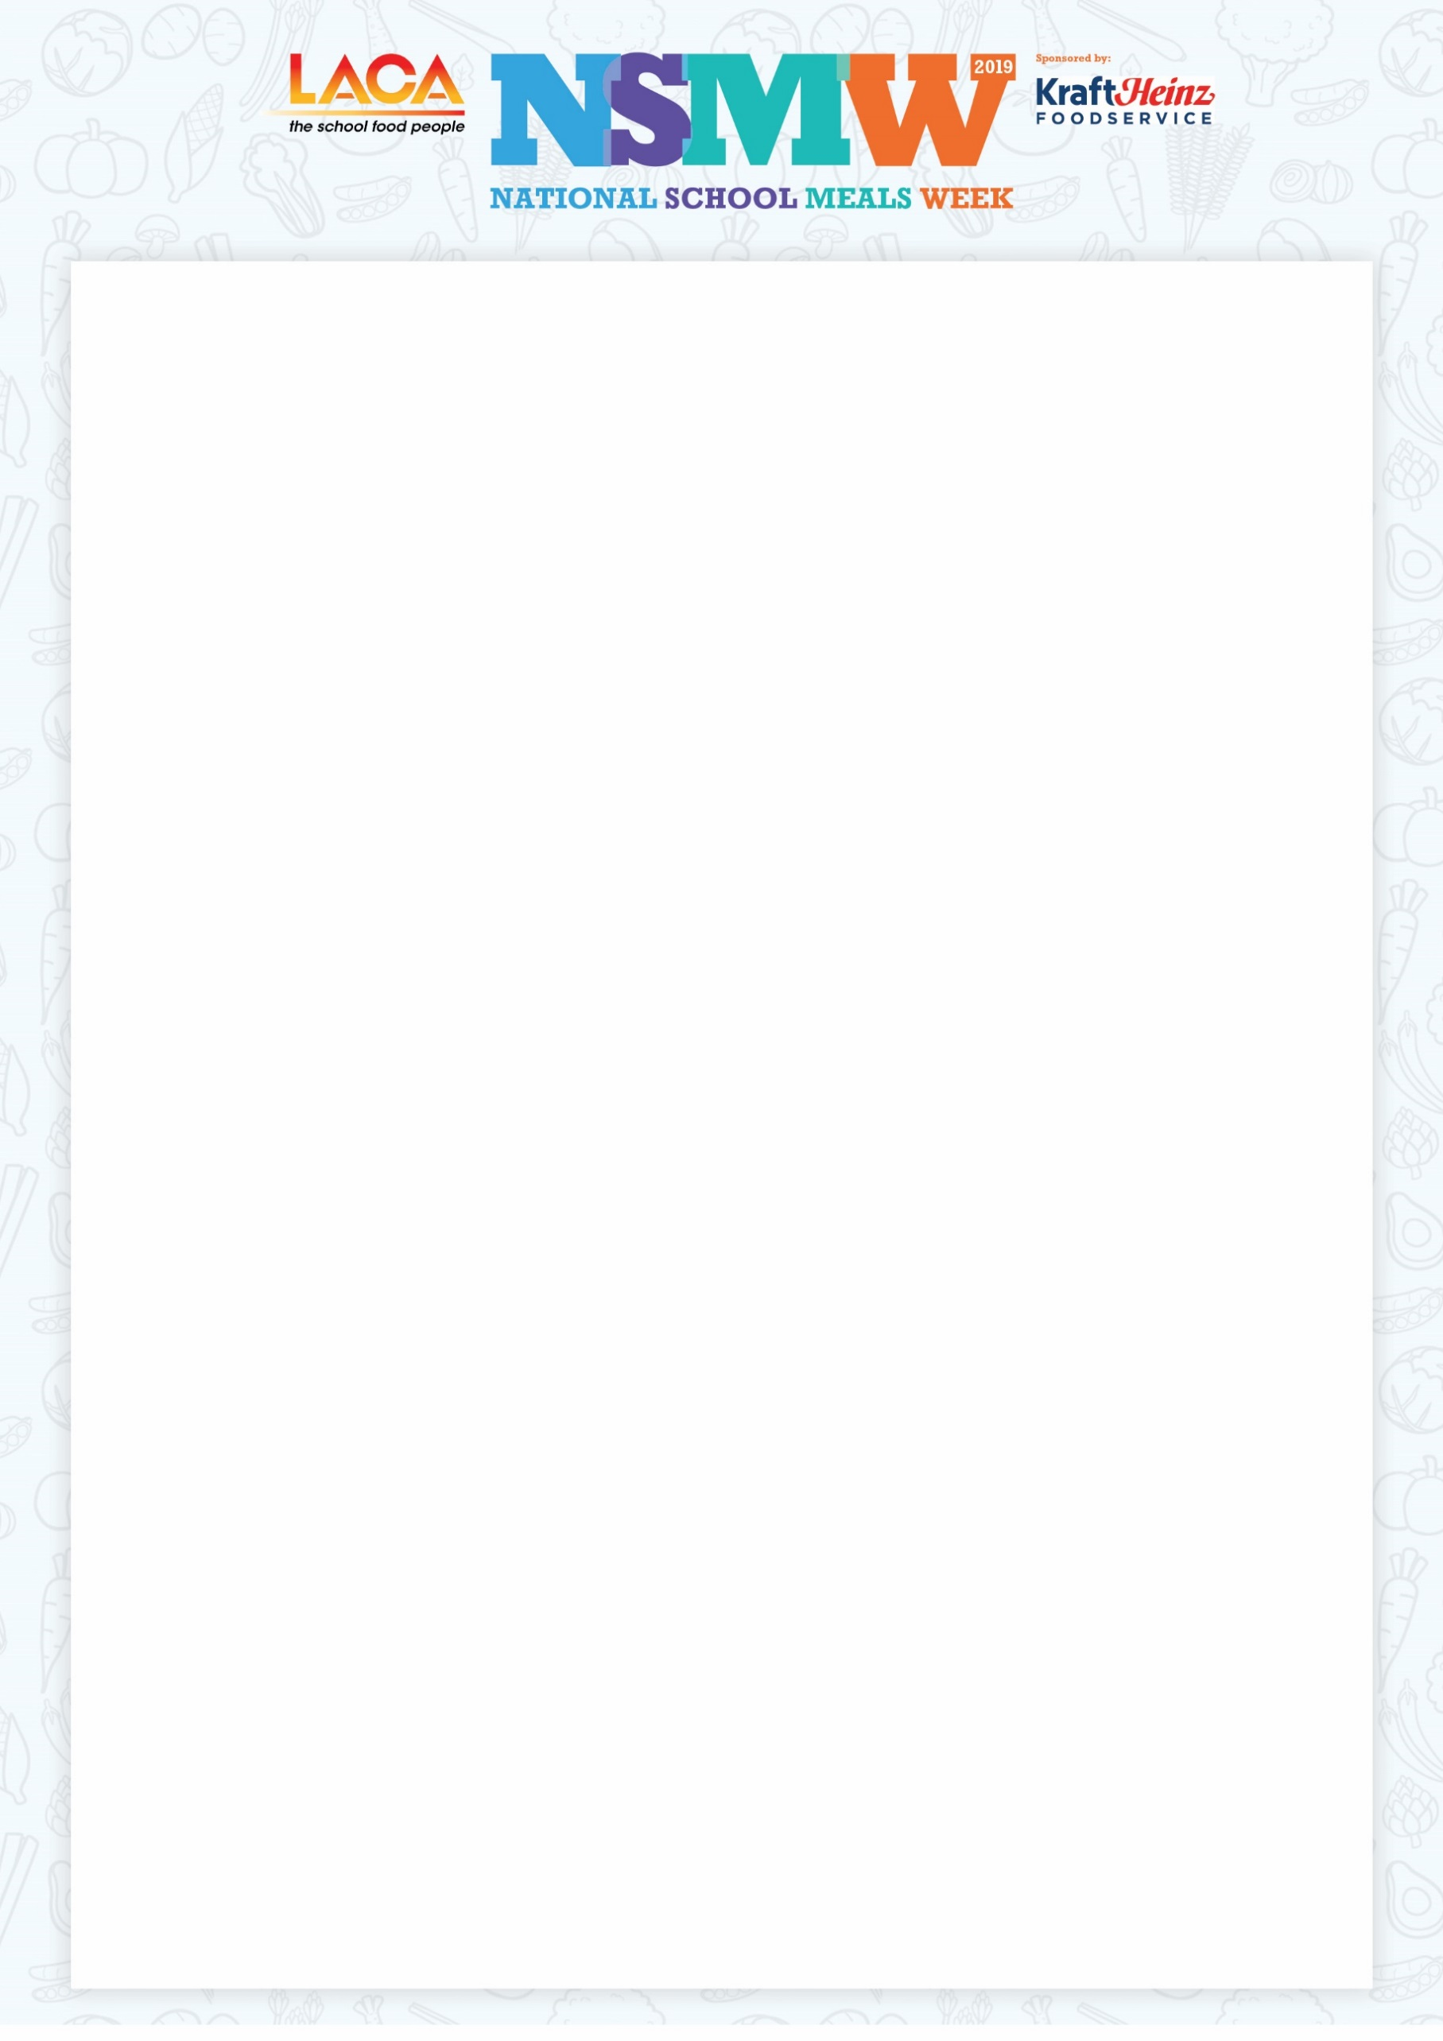

(Insert school/company logo here)

Dear parent,

LACA National School Meals Week is the one week in the year when we celebrate all that is great about today’s school food, with this year’s activities scheduled for 11th - 15th November 2019.

Schools across the country are promoting the ‘Taste for Yourself’ campaign, which is an initiative for pupils who don’t have a school meal to sample a delicious two course lunch. We would also like parents and other family members to come into school and have a meal with us and see for themselves the quality and variety on offer in the school dining room.

LACA (The School Food People), sit at the heart of school food delivery, representing over 3,300 different organisations and individuals, all dedicated to ensuring that our children get the benefits from a healthy, nutritious school lunch.

Enjoying a nutritious two course school meal at lunchtime supports academic attainment, helps children to concentrate better and has a positive impact on behaviour in the classroom.

Education catering has improved dramatically in the last decade or more and we would be delighted if you would accept this invitation to enjoy a meal with us that will cost you less than the price of a cup of coffee on the High Street.

Let us know which day of the week is best for you and an early reply to (insert name and contact details including DD telephone numbers and email addresses) would be appreciated. We can then confirm timings etc. You are of course most welcome to bring a guest and please let us know if that will be the case.

I look forward to hearing from you.